**No 20: Call Invoiced but unable to credit to change the customer, or add additional costs.**

First step is to be sure the user who is doing the correction has the Credit checkbox or the warranty invoicing and every other checkbox on his/her worker checked.

From the service call or the project module open up the related subproject behind the segment and go to the posted transaction as seen on the screenshot

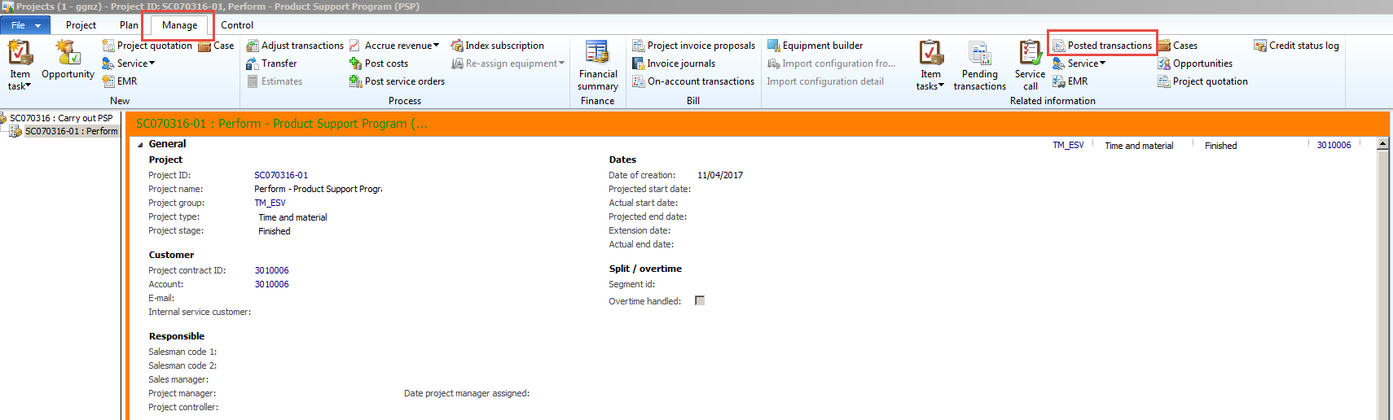

From here select the Fully invoiced transaction and use the Select for credit note bill function as seen on the screenshot and deselect every transaction on all tabs and press ok.

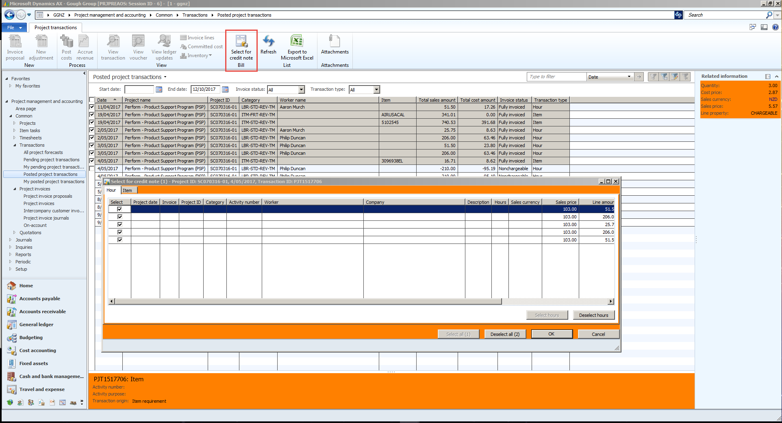

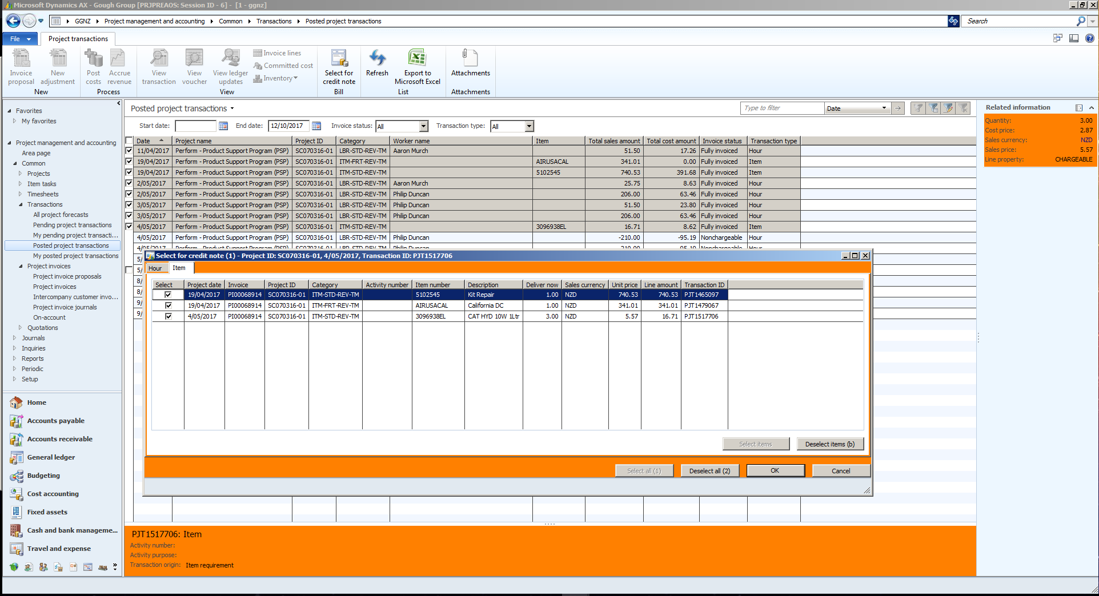

This was the root of the problem, you should not use the standard AX project processes on a service related NAXT project crediting.

Once it is unselected you can back to the segment transactions, transaction details, sales tab and check the transaction status, you should not see selected for credit note anymore, instead invoiced.

If every transaction is clear you may proceed and credit i ton the call and change the customer as usual.

If you are changing the customer but you have warranty already attached, it wont let you because we have a setting on the Customer that needs to be removed to allow the change

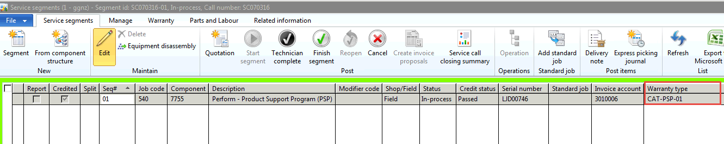

Accounts recevable/Customers/All Customers/ filter on this Customer 5000271. Go to the Setup tab and remove the tick from ’Block manual selection’. Come out of hte screen and then change the customer

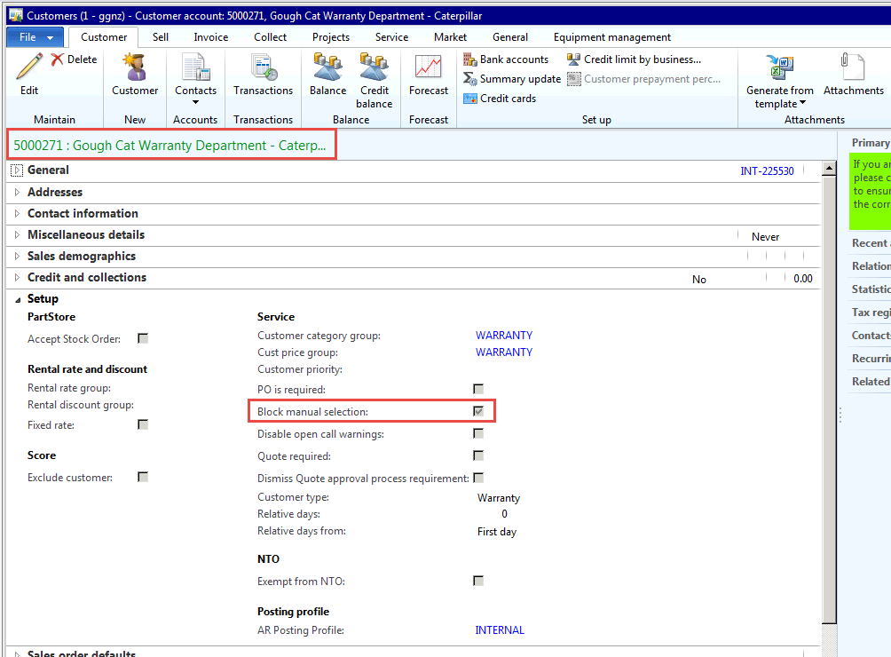

Now remember to go back and put the tick back on.